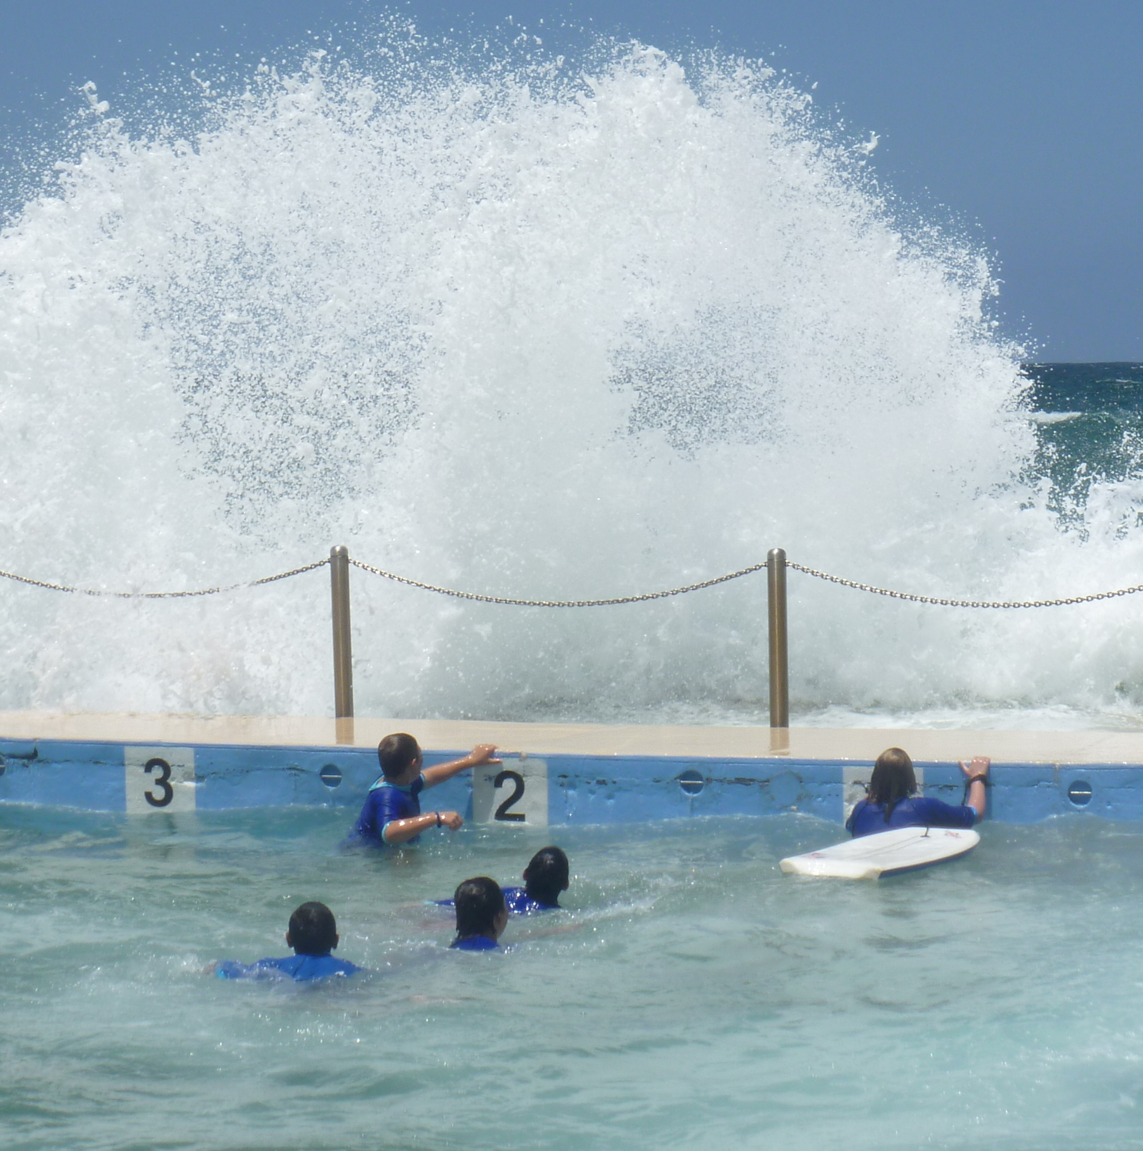
Stewart House School
Annual School Report
5515
2012
Our school at a glance

Stewart House School is a co-educational, residential school located on the beachfront at Curl Curl on the Northern Beaches of Sydney.

Our goal is to develop children’s social and emotional skills and promote a healthy and active lifestyle.

Principal’s message

Stewart House School continues to provide a nurturing, respectful and caring environment for students needing a break from home due to ill health, emotional or other distress, financial or social disadvantage, isolation or difficulties in coping at school due to a lack of skills.

All programs in the school and “out of school hours” program remain clearly focused on developing children’s social and emotional skills and promoting a healthy and active lifestyle. The goal of the school’s management strategies, organisation and procedures is to create a safe and supportive school culture that enhances engagement with peers and adults within an environment that supports a dynamic learning program.

During 2012, the school was able to provide added student assistance through the appointment of a Student Welfare Worker two days a week. Funding through National Partnerships provided professional learning for staff to implement social and emotional learning programs to better meet the needs of students with complex learning needs and students with an Aboriginal heritage.
The focus of the implementation for the National Partnerships for School for Specific Purposes is the “The Four Rooms of Change” program and enhancing resilience for both staff and students.
Spotless are contributing to a minor maintenance grant for the refurbishment of the timber verandahs and to update the four school bathrooms which are in original condition. There will also be funding to replace the school kitchen so that facilities are more appropriate to allow student cooking classes. This work will be completed early 2013.
The students attending Stewart House have enjoyed a wide range of experiences due to the generosity of agencies that provided access to their facilities at no cost. We appreciate the support of Taronga Park Zoo, the Museums in Sydney, NSW Ferries, Sydney Aquatic Centre, the Aquarium at Darling Harbour, Surf Live Saving Australia, indoor pools in the city and suburbs and the IMAX Theatre.

Students relaxing at the Sydney Aquatic Centre.

I certify that the information in this report is the result of a rigorous school self-evaluation process and is a balanced and genuine account of the school’s achievements and areas for development.
Marilyn Bourne. B.A., Dip. Ed., Dip. Cont. Ed., M.A., M. Spec. Ed. (ED/BD), MAPS.

School context

Student information
It is a requirement that the reporting of information for all students must be consistent with privacy and personal information policies.
Students attending Stewart House were selected by principals as being in need of respite care due to family breakdown, school or family crisis and social or geographic isolation. Information provided by home schools and parents/ carers is summarized so that the staff is aware of and can accommodate the stressors in individual children’s backgrounds.
In 2012, 1624 mainstream students attended Stewart House from 829 schools across NSW and the ACT in 19 groups staying 12 days each.

Of the total, 140 students, or 9% of the intake for 2012 spoke ‘Languages Other Than English’ and 44 students or 3% were return visitors, which was half numbers of return visitors in 2011.

Data collated on student admissions during 2012 identified reasons for inclusion in the program as being;
- Isolation 243 students is 15% of the intake,
- Economic disadvantage and/ or lack of opportunity 1149 students is 71% of intake.
Each of the 20 groups in 2012 comprised 90-95 students, aged five to sixteen years.
There were two special education groups in 2012 with one being allocated to country and one to city students. In total, 120 students with special needs and their staff attended in 2 groups staying for 4 days each.
To accommodate the second group in 2012 and a third group in 2013 one School Development Day each year was used for student visits.

Student enrolment profile

The majority of students attending (70%) are aged from 9 to 12 years of age, a similar ratio to previous years.

Student referrals and school counsellor contact with home schools provide staff with information to enable them to accommodate the needs of individual children while at Stewart House.
Student enrolment profile 2012
The majority of students attending Stewart House are males in upper primary aged 10 to 12 years of age.
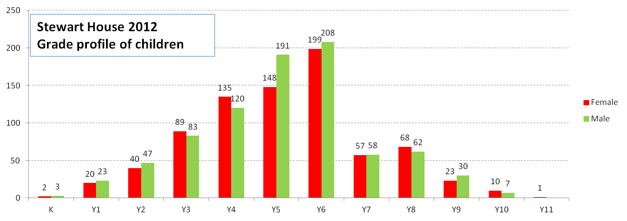
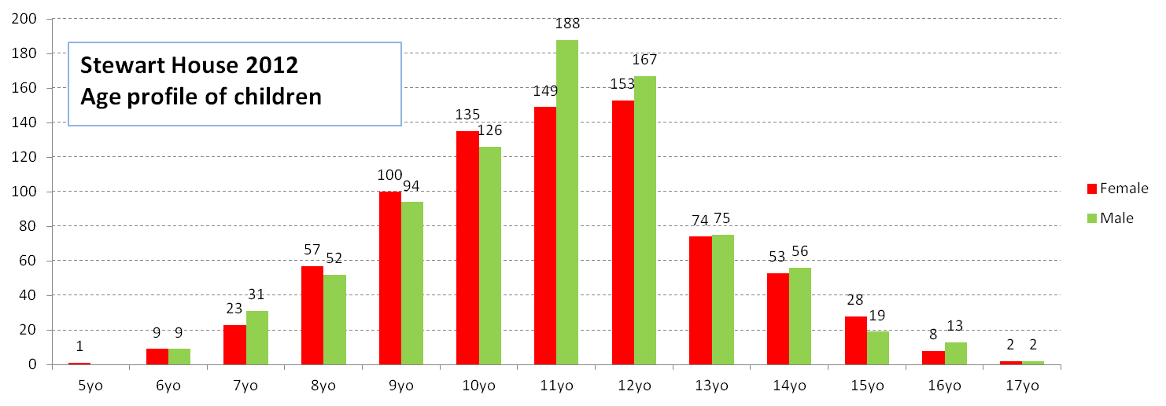

Information provided by home school teachers identified the following numbers of students as needing support, a similar percentage to 2012.

- 597 students (37%) needed help with peer/adult interactions,
- 165 students (10%) were not accepted by peers,
- 294 students (18%) had behaviour problems,
- 579 students (36%) needed social skills development,
- 525 students (32%) needed help with emotional resilience.

Staff information
It is a requirement that the reporting of information for all staff must be consistent with privacy and personal information policies.
Teachers are drawn from primary, secondary and special education with a range of skills and experiences in Student Welfare, Visual Arts, PD/H/PE and Technology. All teachers have extensive experience in managing behaviour and assisting students with additional support needs. Teachers share a common interest in teaching children with welfare and behavioural needs and are proactive and flexible, catering for individual students.

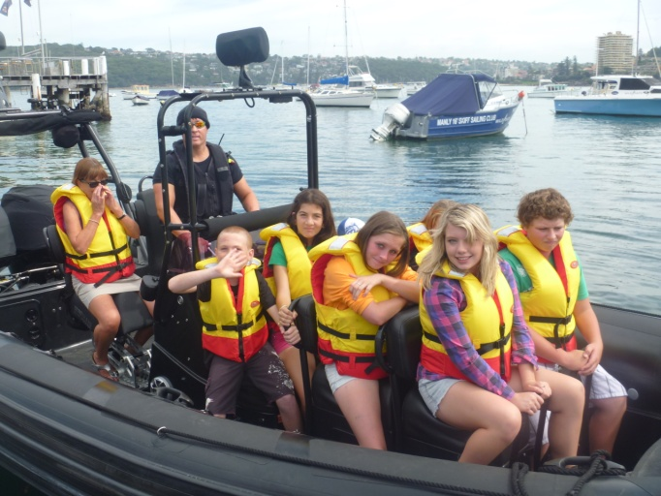

Students enjoying a jet boat ride in Manly

The non teaching Assistant Principal position was filled by an incentive transfer at the beginning of 2013.

Staff establishment

Position | Number
Principal | 1
Assistant Principal(s) | 2
Classroom Teachers | 5.6
Teacher Librarian | .2
Counsellor | 1.5
Aboriginal Education Officer | 1
Student Learning Support Officers | 3
School Administrative Staff | 1.4
General Assistant | .4
Total | 16.1

The National Education Agreement requires schools to report on the Indigenous composition of their workforce. Students of Aboriginal heritage attending Stewart House in 2012 made up 22% of student intake. During 2012 the Aboriginal Education Position was filled with a permanent employee allowing student needs to be met and a program enhancing Aboriginal Culture to be introduced.

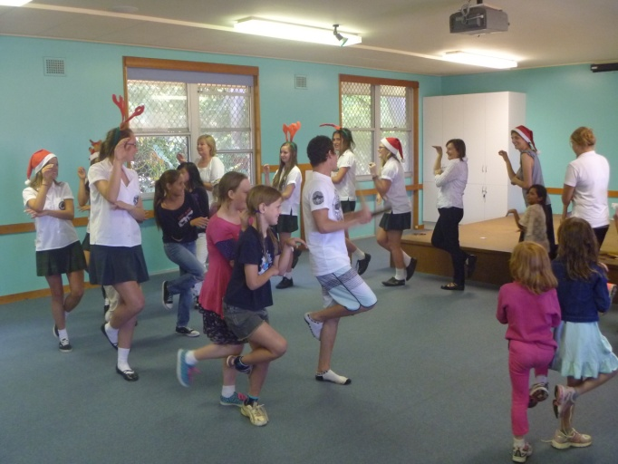

Aboriginal Dance Lesson

Staff retention
Teaching staff are employed with three year tenure to ensure that they do not lose skills in mainstream curricula. Teachers return to the mainstream after their appointment as special education is not a prerequisite for employment.
In 2012, two teachers were successful at interview in gaining a further three year appointment. This was beneficial to the staff as the four teachers leaving late 2011 would have been a major difficulty in commencing the year, particularly as teachers drive the bus fleet as part of their duties.

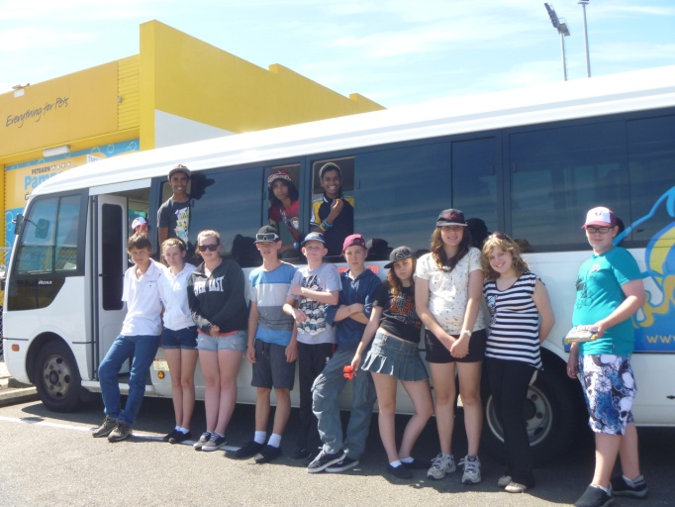

Students on an excursion

Teacher qualifications
All teaching staff are compliant with the professional requirements for teaching in NSW public schools.

Qualifications | % of staff
Degree or Diploma | 50%
Postgraduate | 50%

All executive staff have completed a Masters of Special Education with one teacher having a Graduate Diploma of Aboriginal Studies.

Financial summary
This summary covers funds for operating costs and does not involve expenditure areas such as permanent salaries, building and major maintenance.
Date of financial summary | 30/11/2012
Income | $
Balance brought forward | 61,536.91
Global funds | 112,596.97
Tied funds | 89,793.94
School & community sources | 10,903.10
Interest | 3,841.76
Trust receipts | 7,934.22
Canteen | 0.00
Total income | 286,606.90
Expenditure
Teaching & learning
Key learning areas | 3,619.30
Excursions | 2,956.34
Extracurricular dissections | 697.01
Library | 0.00
Training & development | 1,073.64
Tied funds | 58,275.23
Casual relief teachers | 34,068.59
Administration & office | 37,850.07
School-operated canteen | 0.00
Utilities | 31,855.53
Maintenance | 8,928.53
Trust accounts | 5,818.75
Capital programs | 0.00
Total expenditure | 185,142.99
Balance carried forward | 101,463.91

Achievements

Arts
The students at Stewart House have completed many varied and exciting art and craft projects throughout their stay. These include clay work and firing, wood work, face masks, laminated autograph sheets and jewellery.
Some students have enjoyed creating animal water colours based on their visit to Taronga Zoo. The aim of these projects is to encourage students to interact with each other and the teaching staff in a relaxed and creative environment. The students take great delight in finishing these projects and are always keen to take them home and to show them to their families and teachers at their home schools.

Sport
Staff participated in the ‘Live Life Well’ program with resources prepared to support skills training lessons for students. Live Life Well at School is a joint initiative between the NSW Department of Education and Communities and NSW Ministry of Health. At Stewart House the program developed teachers’ knowledge and skills in teaching nutrition and physical education as part of the Personal Development, Health and Physical Education (PD/H/PE) syllabus. In addition to the Social and Emotional Wellbeing curriculum and comprehensive health screenings, fundamental movement skills and healthy eating are now explicitly taught in all classes. All students participate in structured skill based games and take home nutrition information packs for their families.

Active After School Sports run two sessions a week for students with sessions from a range of areas including yoga, AFL, dance and ball skills. Surf Life Saving Australia assist teachers to organise games on the beach and students play ball games on visits to local parks following excursions.

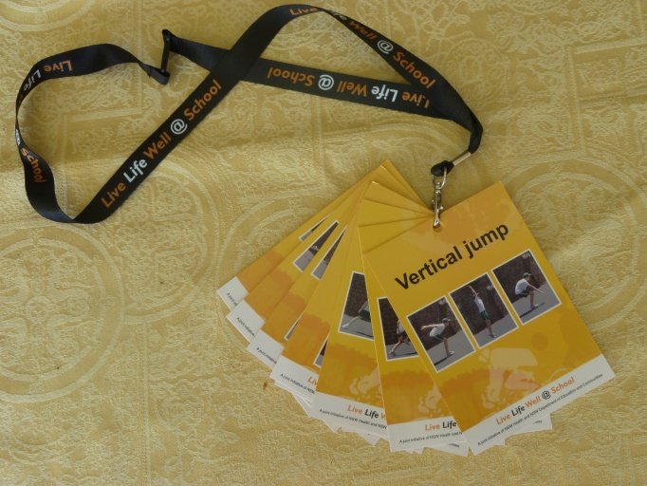

Live Life Well

Swimming is an integral part of the Stewart House School and Recreation Program.

All students participate in swimming activities at ocean pools or indoor heated pools during their visit.

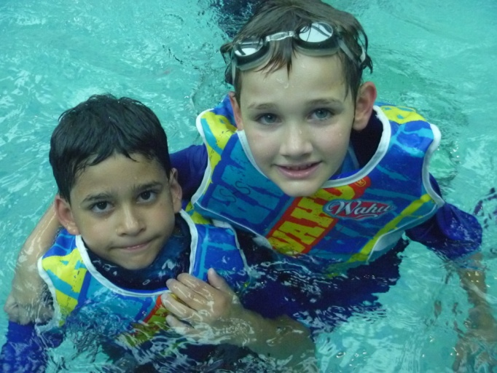

Students at Sydney Aquatic Centre

Funding provided by the Live Life Well program was used to purchase life jackets to ensure high standards of safety standards when swimming and also contributed to the purchase of rash shirts.

All students are fitted with rash shirts for easy identification and non swimmers in the lower grades also fitted with life jackets. Students who complete the swimming test of 25 metres are fitted with blue bands with non swimmers wearing yellow bands according to DEC policy.

Yoga, Meditation and Relaxation

In 2013 child specific yoga, meditation and relaxation has been incorporated in the school and after school programs with positive results.

Students have had fun exploring what their bodies can do and accepting themselves as they are. They have learnt skills to help them minimise distractions, focus on the present and slow down to still the body and mind. Students have expressed feelings of increased confidence, a realization of the power of the mind and gratitude for the skills they have learnt and can use in the future.

Significant programs and initiatives
The Student Welfare program
Student Welfare programs have a high priority at Stewart House. They enhance student outcomes by assisting children to develop confidence, trust in others and build self esteem. These programs include our social skills lessons and reward programs that enable children to change their perception of their world and themselves.
The student management program is implemented in a limit setting environment where prosocial and adaptive behaviour is shaped by the consistent use of positive reinforcement. Our goals are for students to learn to be responsible for their own behaviour.
Children are supported in many ways with positive consequences for prosocial behaviours including extrinsic rewards such as;
- Dolphin dollars to acknowledge prosocial behaviours in individual classrooms and the playground,
- Merit certificates at assembly that are linked to prosocial behaviour,
- Treasure board stickers to put on the Treasure Board each day.

Life Education

Life Education continued during 2012 and will be funded for 2013. Life Education complements the Stewart House Social Skills Programs with the emphasis on healthy choices for older students, respecting others and a healthy lifestyle. During 2013 an amphitheatre will be constructed in a space in Stewart House as a permanent room for Life Education with the mobile van no longer needed. This will reduce the cost of the program and allow the lessons to be offered to all groups during the year.

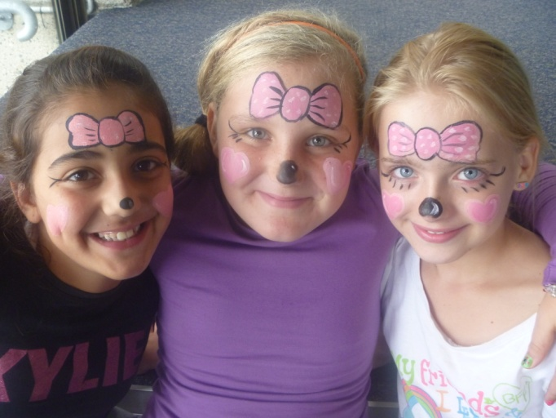

Face Painting by Ladies of Variety

Social skills
Junior Program
The Junior Social and Emotional
Skills program was reviewed and improved to ensure positive student participation. It has continued to be most relevant and beneficial to our students and has produced positive outcomes in the classroom and beyond.
Students engaged in four specific lessons focusing on:
- Learning appropriate ways to meet peers and initiate friendships,
- Maintaining friendships using positive behaviours,
- Identifying and acknowledging personal strengths and strengths of their peers,
- Problem solving skills, developing positive attitudes through positive self talk,
- Developing resilience in order to cope with adversity.

Students continued to make substantial improvements throughout their two week stay with teachers adapting the lessons to suit the specific needs of the students in their classes. The lessons are now deeply embedded into our fortnightly program and continue to evolve in response to student needs. It has again proven to be a highly successful program for our unique setting.

Senior Program
The senior social skills program incorporates the Personal Development/Health/Physical Education Years 7-10 syllabus outcomes of enhancing students’ self-esteem and sense of self, improving their capacity to manage challenging circumstances, developing caring and respectful relationships and developing skills that enable students to adopt and promote healthy lifestyles.

Our program aims to build emotional resilience and problem solving abilities, encourage peer learning and promote self confidence when dealing with difficult or anxiety provoking situations.

Lessons cover the following topics;

- Acknowledging and building on personal strengths,
- Using positive self talk,
- Identifying support networks and raising awareness of the importance of reaching out to others,
- Using a five stage process for solving problems,
- Exploring different coping strategies to build resilience,
- Exploring ways to deal with bullying,
- Setting personal goals.

Aboriginal Education
Aboriginal Education has been an integral part of the Stewart House program due to the 355 (22%) Aboriginal students who visited in 2012.
The children have visited The Bobbin Head, West Head and Bayview Aboriginal sites while studying bush tucker and the local flora and fauna and the Dreamtime. They also participate in Aboriginal dance, song and art during their visit.
Students commence each daily assembly with Acknowledgement of Country.

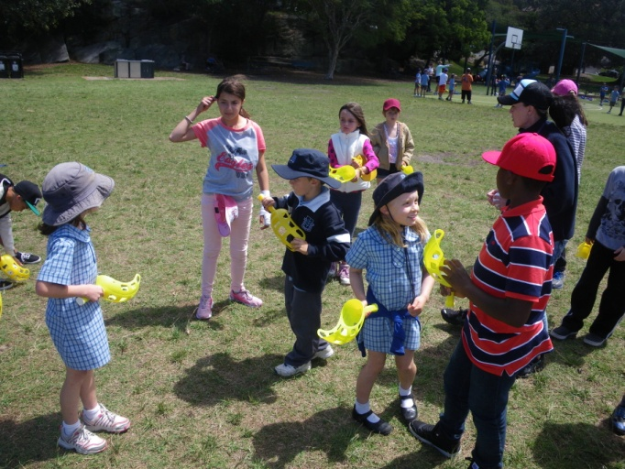

Aboriginal Games with Balgowlah Heights P S

Reading Program

Throughout the year the school has continued to promote reading and the importance of the skills and understanding needed to achieve higher levels of education. We have been fortunate to have had thousands of books donated by various institutions and individuals. These books are given to the students who attend Stewart House.

Students are encouraged to select books which challenge their individual reading skills and also to select early learning literature which they can use to encourage siblings who have yet to enter the school system. Approximately 350 books are distributed to students per fortnight totalling close to 6000 books per year. Promoting the love of reading and the literacy skills gained will benefit students and their families.

Surf Lifesaving

Surf Life Saving staff attend Stewart House School every Wednesday with 45 students participating in the program each week. Students learn about beach safety including identifying rips and the sea creatures to beware of. After the presentation the lifesavers play games on the beach with school staff. The children swim in the local pool when the weather is warm.

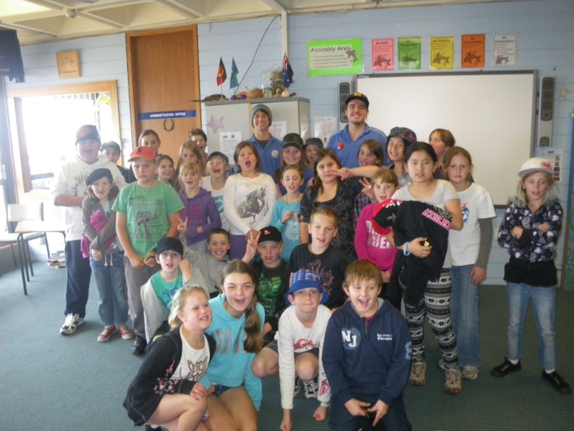
Students with staff from Surf Lifesaving

National partnership programs
Stewart House School received funding for National Partnerships SSP grants to provide programs to promote the teaching of social and emotional skills to a student group with complex learning needs and of Aboriginal heritage.
The focus of our intervention for the social and emotional learning programs is the The Four Rooms of Change Program and developing resilience in both staff and students.

The Four Rooms of Change
The Four Rooms of Change is a theory that helps children and adults to understand and take responsibility for their emotions and behaviours. The theory says that there are four frames of mind that we all experience.

The Four Rooms are:

- Contentment: Things are OK, I am feeling alright about the world,
- Denial: Things are really hard and I don’t want to have to face up to them,
- Confusion: I have to make a choice about something and I don’t know what to do,
- Inspiration: I feel really good, things are exciting.
Children have been encouraged to see that we all have these feelings and that we move through these Four Rooms. While it is good to be in Contentment or Inspiration, at times we will be in the other two rooms where it does not feel so good. The Four Rooms helps the children understand why they feel ‘good’ or ‘bad’. The program ran with great success in schools in Sweden and Finland, and started in Australia in 2010. The program uses Four Faces to represent the Four Rooms and children are asked to share, with their friends and teachers, how they are feeling. This helps teachers to help students and also helps children support each other. We talk about this as increasing emotional intelligence.

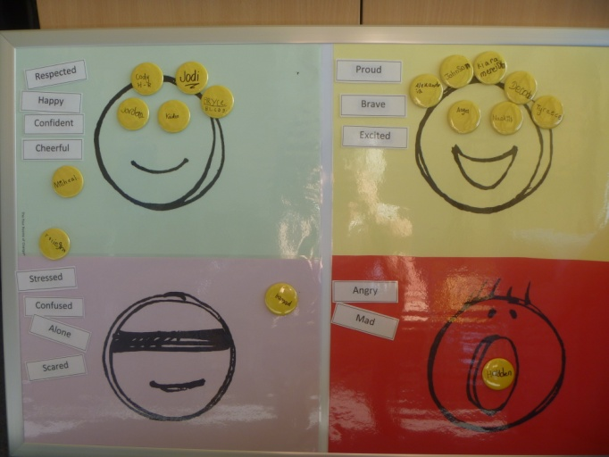
Student magnets on the Four Rooms Board

Materials have been prepared for implementation at the beginning of 2013 with information to be sent to parents and schools explaining the concepts involved in the program.

Resilience

Model of 7 Elements of Resilience

A number of teachers have attended professional learning to explore the research on Resilience and were presented with current research models to be developed in relation to both staff and student resilience.

Michael Ungar’s model of the seven critical elements that are protective factors in developing resilience was enhanced with practical examples for the school environment.

Other programs
Student Welfare Worker
During 2012 the school was successful in gaining funding for a Student Welfare Worker. The Student Welfare Worker will be facilitating a lesson on bullying for all students in collaboration with the ‘Relief from Face to Face’ teacher. The lessons will teach students strategies that are adaptive and strength building to address bullying.

Health programs
Triage nursing
Nurses supervise the administration of medication and run a triage system for students needing medical attention on a daily basis.

The management of medication included;
- supervising 150 students (9%) who arrived with allergies,
- 423 students (26%) arrived with health issues,
- 132 students (8%) were prescribed ADHD/ADD medications,
- 179 students (11%) on other prescribed medications and
- 271 students (16%) on asthma medications.

Of the children attending during 2011, 855 (51%) received triage by nursing staff. Of these 89 (5%) visited local medical centres or hospitals.
Audiometry
Each fortnight nursing staff from Northern Sydney Area Health assess all the children’s hearing. In 2012 9% of the students screened were identified with hearing problems requiring further investigation. Twenty five children attended Macquarie University for advanced testing.
Optometry
Of the children assessed by the optometrist and students from NSW University, 31% had vision problems. Teachers Health provided 75 new sets of glasses with students able to choose the frames that best suited them.

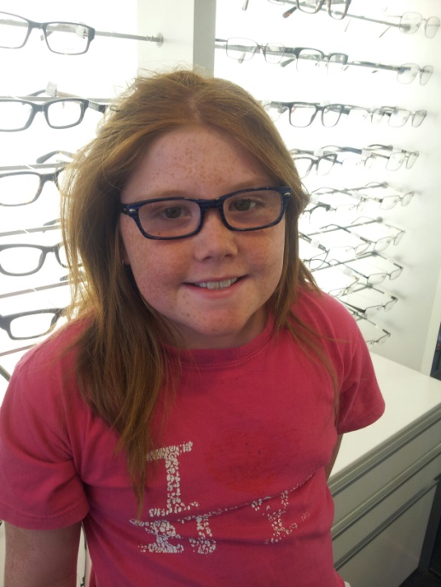
Glasses from Teachers Health Society

Preventative dental health program

Dental health of students continues to cause concern with 100% of students seen by dental staff in 2012 requiring preventative or restorative treatment to their teeth. Twelve children received emergency dental treatment at Mona Vale Hospital for advanced decay.
Staff from the school and ‘Out Of School Hours’ (OOSH) program present different aspects of dental hygiene to the students. This preventative dental health program continues to be jointly funded by the Northern Sydney Area Health, Colgate and Brighter Futures.
Throughout 2012 all students received a toothbrush and toothpaste with supervision when brushing their teeth and dental lessons about the care of their teeth and procedures for brushing.

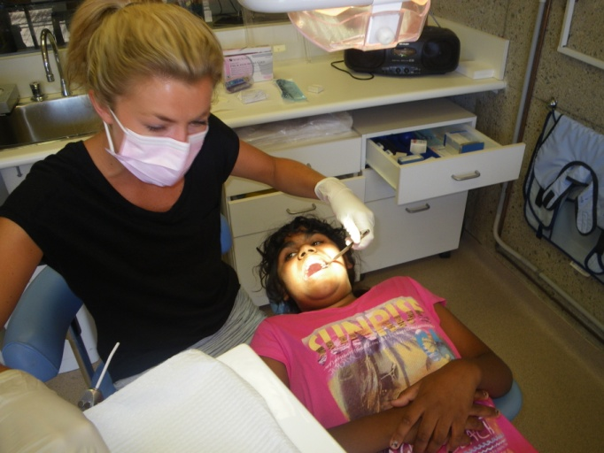

Dental therapists provide on site service

Progress on 2012 targets

Target 1

To develop Stewart House School as a centre of excellence for social and emotional learning.
Our achievements include:
- Three sessions of professional learning in the ‘Four Rooms of Change’ as a means of teaching emotional skills with materials prepared to commence the program in 2013,

- Completion of the first two sessions of the Kidsmatters Program,

- PBL implementation across the site,

- The social skills junior and senior programs reviewed.

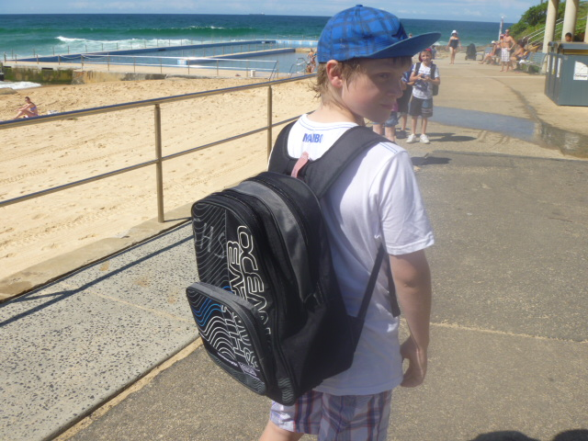

New Backpacks for all students.

Target 2
Improvement of the physical education program to teach students sports skills.

Our achievements include:

- Skills training in AASC,

- Teachers implemented the Live Life Well Program with in-school professional learning on skills teaching. Staff from Surf Life Saving Australia assisted with ball skills,

- Materials were prepared for teacher prompts and information sent to parents.

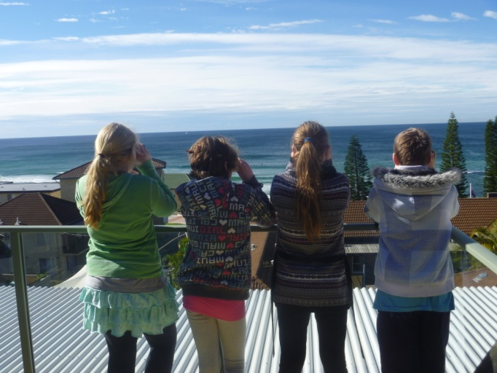
Students whale watching with new binoculars

Target 3
Integrate Aboriginal cultural activities into the curriculum for ‘relief from face to face’ and class programs using the local area, the indigenous garden and the performing arts.
Our achievements include:

- Staff incorporated Aboriginal dance, song and art into the curriculum for all students,
- Revision of Indigenous games activities for all staff,
- Sharing skills with staff and students from Balgowlah North Public School.

The indigenous garden has not been increased in size but clearing of the larger area has commenced.

Program development for the ‘relief from face to face’ program based on the local environment has commenced and will continue in 2013.

Target 4
Promoting Stewart House educational programs to the wider school community in NSW to provide professional learning on social and emotional skills.

Our achievements include:
- Videoconferencing used to present material on Indigenous games to the Caring for Country participants,
- Student performances from Stewart House School shared with Goodooga Public School students,
- National Partnerships program to be shared on a Weebly for Northern Sydney Region Schools for Specific Purposes.
Professional assistance with digital presentation skills including; movies, powerpoint presentations and videoconferencing will continue in 2013.

School evaluation
NSW public schools conduct evaluation to support the effective implementation of the school plan. In 2012 our school carried out the annual evaluation of the relationship between bookings and behaviour management strategies across the site.

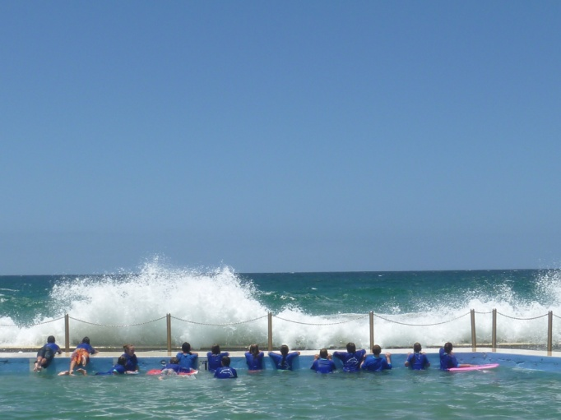

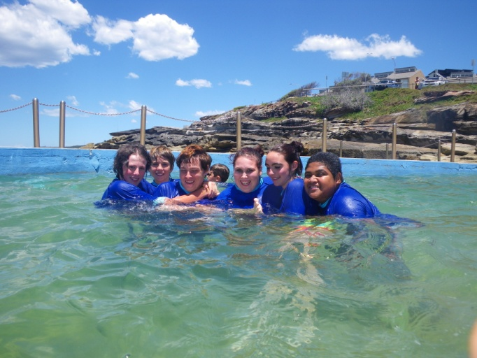

Students enjoying the pool

Educational and management practice
Background
Data collection over the past four years identified approximately 50% of students with emotional, social and behavioural support needs. Students are also identified at referral with Aspergers Syndrome, ADHD/ADD and Anxiety Disorders. Our team does an excellent job providing engaging programs that cater for students with complex learning needs. To successfully manage behaviour, welfare and discipline we employ a very simple level system that children readily understand and follow.

This is outlined below;

Yellow: Student has misbehaved and requires a formal interview with Executive.

Orange: Student has persistently misbehaved and ignored supports/ interventions implemented by staff. The home school is notified and liaises with Stewart House to develop a support plan.

Red: Student behaviour is unacceptable and has had a significant impact on the care, welfare and safety of others. Student is discharged from Stewart House.

Findings and conclusions
The combination of student groups was changed in 2012 to include a city/ country mixed group. The previous two years 2010 and 2011 were comprised of two city or two country groups. There has been 50% decrease in orange bookings in 2012 compared to the bookings in 2011.

Table 1. Comparison Behaviour Bookings 2008 to 2012
2008 2009 2010 2011 2012
Yellow | 78 | 60 | 66 | 67 | 47
Orange | 17 | 7 | 10 | 26 | 13
Red Discharge | 7 | 6 | 9 | 7 | 3
Totals | 102 | 73 | 85 | 100 | 63

Future directions
Student groupings for 2013 include a city/ country mix for all groups where possible. This will continue in the future.
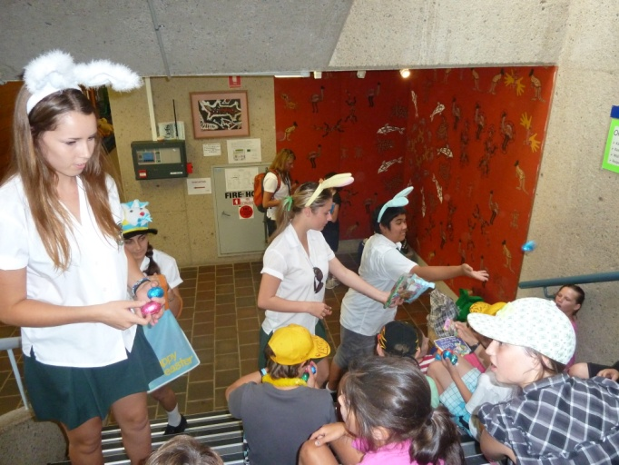

Students from Forest High School as Easter Bunnies.

Professional learning

- Caring for Country
- ARCO training
- DEC Mandatory Training; WHS, Child Protection, Code of Conduct, First Aide, Anaphylaxis
- CHERI conference on Resilience
- Michael Ungar Resilience, Sydney Uni.
- Four Rooms of Change
- Kidsmatter
- Aboriginal Studies Association
- TAFE Certificate in Aboriginal Studies

School planning 2012—2014
The school planning policy provides direction for the preparation and implementation of school plans including the identification of priority areas, intended outcomes and targets that are consistent with the NSW State Plan and the Department’s planning documents.

School priority 1

Outcome for 2012–2014
Continued improvement of the social and emotional learning program.
2013 Targets to achieve this outcome include:
- Implementation of the Four Rooms of Change Program,
- Professional learning in models of resilience for staff,
- Introducing a model of resilience for students.
Strategies to achieve these targets include:
- Lesson formats and resources prepared for the Four Rooms of Change,
- Introducing Michael Ungar’s model of resilience for staff to increase personal awareness of resilience,
- Implementation of the model into the classroom.

School priority 2

Outcome for 2012–2014
To implement the use of technology across the site to replace written documentation.
2013 Targets to achieve this outcome include:
- Recording relevant student information on a common database with all staff on site. Forms include student information, health, behaviour, student reports and maintenance reports,
- Investigating online applications,
Strategies to achieve these targets include:
- Professional learning in accessing common database,
- Reviewing and revising formats of files to enhance data sharing and collection.

School priority 3

Outcome for 2012–2014
To develop a personalized learning plan in social and emotional skills to improve the liaison between Stewart House School and home school for students at risk.
2013 Targets to achieve this outcome include:
- Teachers and support staff currently identify students experiencing difficulties in social and emotional development and in need of additional support during the first few days of a visit and record student difficulties on a database. Action plans are put in place to address these behaviours,
- A Personalised Learning Plan will include observed behaviours at Stewart House, outline our program targets, the strategies for management used during the visit and include suggestions to assist with skill development on leaving.
Strategies to achieve these targets include:
- Identify and record information on students at risk early in the stay,
- Development of a proforma for a PLP online to be emailed to the home school principal with the Stewart House Report at the conclusion of the visit,
- Liaison with principals in reviewing a draft PLP proforma,
- Completion of the PLP for each identified student at risk will be sent to the student’s home school principal at the end of the group. This will include database of items to be copied into reports for ease of completion of PLP by teachers.

About this report
In preparing this report, the self-evaluation committee has gathered information from evaluations conducted during the year and analysed other information about the school's practices and student learning outcomes. The self-evaluation committee and school planning committee have determined targets for the school's future development.
Marilyn Bourne, Principal
Roy Goodenough, Assistant Principal
Vanessa Murphy, Assistant Principal
Ruth Harris, School Administrative Manager.

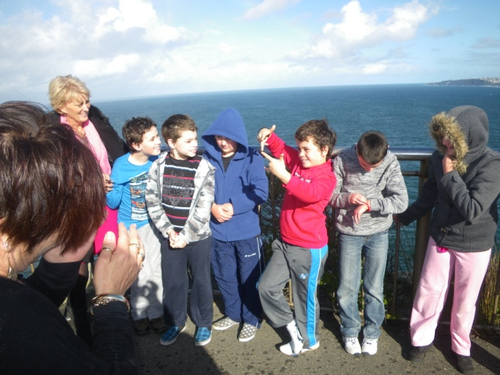

Students in support schools/ classes with their staff

School contact information
Stewart House School.
22 Ellen Street, Curl Curl, 2096.
Ph: 9938 3822.
Fax: 9905 6491.
Email: stewarthou-s.school@det.nsw.edu.au.
Web: www.stewarthou-s.school.com.au.
School Code: 5515.
Parents can find out more information about Annual School Reports, how to interpret information in the reports and have the opportunity to provide feedback about these reports at:
http://www.schools.nsw.edu.au/asr

